Assignment 1: Group 8

Research

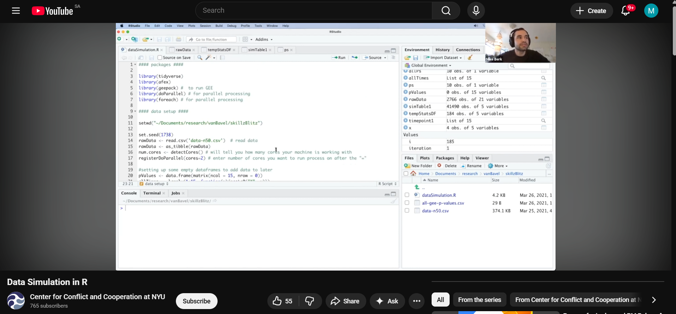
We did some digging on YouTube and we found a video on how to simulate data in R.

We only had to watch the first part of the video for the functions we needed to use for our case of data simulation.

We went to Gemini and asked for it to explain the assignment further and give us some tips on how we could be unique.
“The goal of this assignment is to simulate a dataset for a linear regression model, first as an observational (messy) set and then as a controlled experimental set. We will then analyse another group's data to "detect" their hidden true model.”
From that We started brainstorming scenarios to use as our case and we resorted to creating a data simulation of students that aims to predict the total monthly expenditure (Y) of a UFS student.
The 5 Predictors (X):
- $X_{1}$ (Binary): Funding Source (1 = NSFAS or Bursary, 0 = Private or Self-funded).
- $X_{2}$ (Categorical): Living Arrangement (1 = On-campus res, 2 = Off-campus res, 3 = Private)
- $X_{3}$ (Continuous): Distance from Campus (KM). This is your continuous variable for discretization.
- $X_{4}$ (Count): Social Outings per Month. A discrete count variable.
- $X_{5}$(Count): Library visits per Month. A discrete count variable,
- $X_{5}$ = Social Outings (-$X_{4}$). This represents the hypothesis that students with guaranteed funding might spend more per outing.

R

Part I: Observational Data Simulation
This script generates the “messy” observational dataset for the UFS Student Expenditure model.
# Set seed for reproducibility
set.seed(2026)
# Number of observations
n <- 100
# 1. X2: Living Arrangement (Categorical: 1=Res, 2=Off-campus, 3=Private)
living_arrangement <- sample(c(1, 2, 3), n, replace = TRUE, prob = c(0.3, 0.4, 0.3))
# 2. X3: Distance from Campus (Continuous - Correlated with Living Arrangement)
distance_km <- ifelse(living_arrangement == 1, abs(rnorm(n, 0.1, 0.05)),
ifelse(living_arrangement == 2, abs(rnorm(n, 5, 2)),
abs(rnorm(n, 12, 4))))
# 3. X1: Funding Source (Binary: 1=NSFAS/Bursary, 0=Private)
prob_funding <- ifelse(living_arrangement == 3, 0.2, 0.7)
funding_source <- rbinom(n, 1, prob_funding)
# 4. X4: Social Outings (Count variable)
social_outings <- rpois(n, lambda = 4)
# 5. X5: Library Visits (Nuisance Variable)
# X5 is defined as a base amount minus 20% of Social Outings (X4)
base_library_visits <- rpois(n, lambda = 15)
library_visits <- round(pmax(base_library_visits - (0.20 * social_outings), 0))
# Interaction Term - Funding * Outings (Used in True Model, but not a standalone column)
interaction_term <- funding_source * social_outings
# 6. The "True Model" for Expenditure (Y)
# X5 (Library Visits) is intentionally EXCLUDED from this equation so its true beta is 0.
living_effect <- ifelse(living_arrangement == 1, 0,
ifelse(living_arrangement == 2, 300, 1500))
error <- rnorm(n, mean = 0, sd = 500)
monthly_expenditure_Y <- 2500 + (1200 * funding_source) + (400 * social_outings) +
(200 * interaction_term) + living_effect + error
# Create the Data Frame
student_data <- data.frame(
funding_source = funding_source,
living_arrangement = as.factor(living_arrangement),
distance_km = round(distance_km, 2),
social_outings = social_outings,
library_visits = library_visits,
monthly_expenditure_Y = round(monthly_expenditure_Y, 2)
)
# 1. Define a color palette for the 3 living arrangements (Colorblind-friendly)
my_colors <- c("#E69F00", "#56B4E9", "#009E73")
# 2. Apply the colors based on the 'living_arrangement' column
point_colors <- my_colors[as.numeric(student_data living_arrangement)]
# 3. Create the scatterplot matrix
pairs(student_data[, c("distance_km", "social_outings", "library_visits", "monthly_expenditure_Y")],
pch = 16, # Uses solid circles instead of hollow ones
col = point_colors, # Colors the dots by living arrangement
cex = 0.8, # Makes the dots slightly smaller to reduce clutter
labels = c("Distance (km)", "Social Outings", "Library Visits", "Expenditure (ZAR)"),
main = "Student Expenditure Correlations (Colored by Living Arrangement)")
# 4. Add a legend so people know what the colors mean
par(xpd = TRUE)
legend("bottomright", fill = my_colors,
legend = c("On-Campus", "Off-Campus", "Private Flat"),
title = "Living Arrangement", bty = "n")

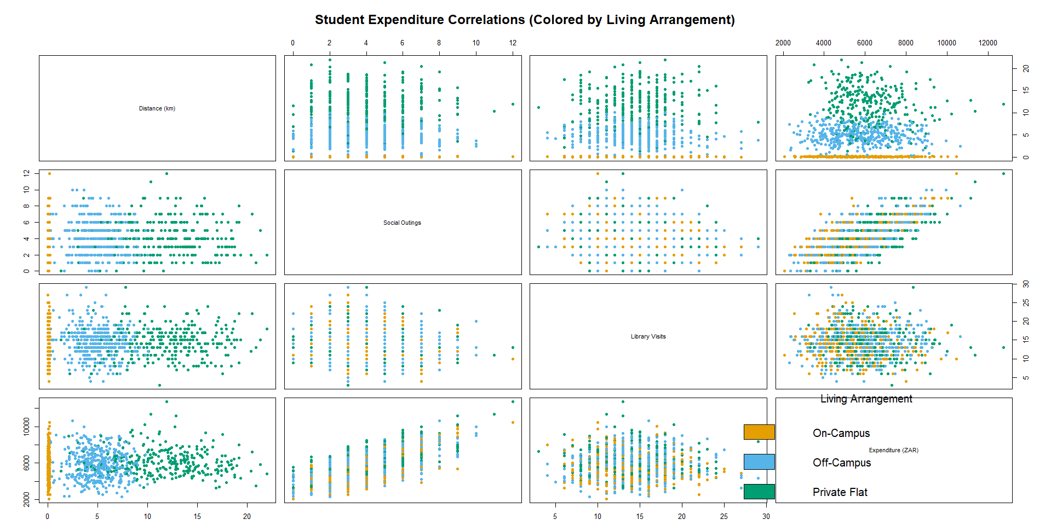

# Save to CSV
write.csv(student_data, "UFS_Student_Expenditure_Data.csv", row.names = FALSE)

True Model: $Y = -2500 + 1200X_{1}+ 400X_{4}+200(X_{1}×X_{4})+X_{2}+ϵ$
monthly_expenditure(Y) = 2500 + (1200 * funding_source) + (400 * social_outings) + (200 * interaction_term) + living_effect + error

- The Base (2500): This is $the β_{0}$ intercept. If a privately funded student $( X_{1}= 0$ ) lives on-campus (Living Effect = 0) and goes on zero social outings $( X_{4}=0 )$, they spend R2500 a month.
- The Funding Effect (1200): Having a bursary or NSFAS directly increases a student's baseline expenditure by R1200, representing more disposable income.
- The Social Outings Effect (400): Every time a student goes out, they spend a base amount of R400.
- The Interaction Term (200): This is the clever part. The formula says$200× Fundings× Outings$ .This means that if you have NSFAS (1), you spend an additional R200 per outing. Privately funded students (0) spend R400 per outing, while NSFAS students spend R600 per outing.
- The Living Effect: This is a categorical shift. Living off campus adds R300, and a private flat adds R1500 to the monthly cost.
- The Error ( $ϵ$ ): This is random normal noise (e.g., N (0, 500)). It prevents the model from being a "perfect line" and represents unmeasured reality, like a student suddenly needing to buy a new textbook or having a medical expense.

